* + 1. Effect of α

1. Is there an α value that you would recommend as clearly the best for this problem?

Yes. I recommend 0.8

Following are the results I got according to α value change.

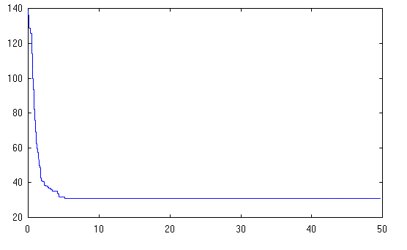

1. Is the convergence profile different for different values of α?

Yes.

1. What happens when alpha is small e.g. alpha < 0.5?

It takes a long time to execute.

1. What happens when alpha is large e.g. alpha < 0.5?

Population, density and the smoothness of the graph getting low. Curves are not accurate than alpha =0.9.

* + 1. Effect of MarkovChainLength

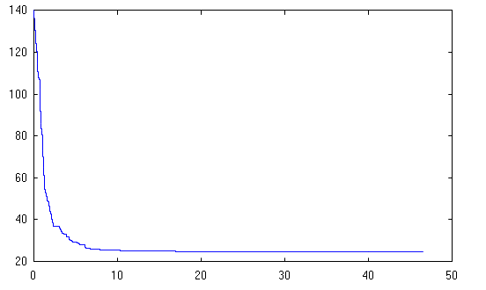

1.Is there a best proportion for the Markov Chain length, taking into account that we are interested in the time as well as the quality of the solution.

Yes. 0.4 is the best propotion.

* + 1. Effect of N

N depends on the speed and memory of the computer. When N is getting larger the sped of the computer gets low.

200, 300, 1000, 5000 and 100000 are values which we picked.

N = 200

Sim Ann = 44.9 seconds

Cut = 289

spectralCut = 65

N = 300

Sim Ann = 56.1 seconds

Cut = 351

spectralCut = 35

N = 1000

Sim Ann = 62.6 seconds

Cut = 1275

spectralCut = 53

N = 5000

Sim Ann = 193 seconds

Cut = 7230

spectralCut = 172

N = 100000

Sim Ann = 146.4 seconds

Cut = 7247

spectralCut = 228

1. Genetic Algorithms
   1. Crossover and mutation

crossover 0.0 - mutation rate 0.0

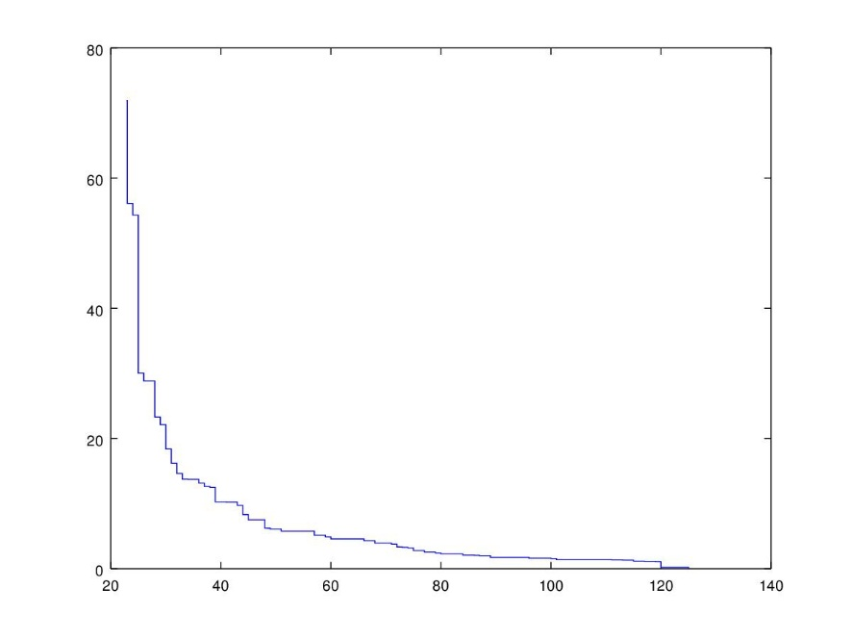

crossover 0.0 - mutation rate 0.1

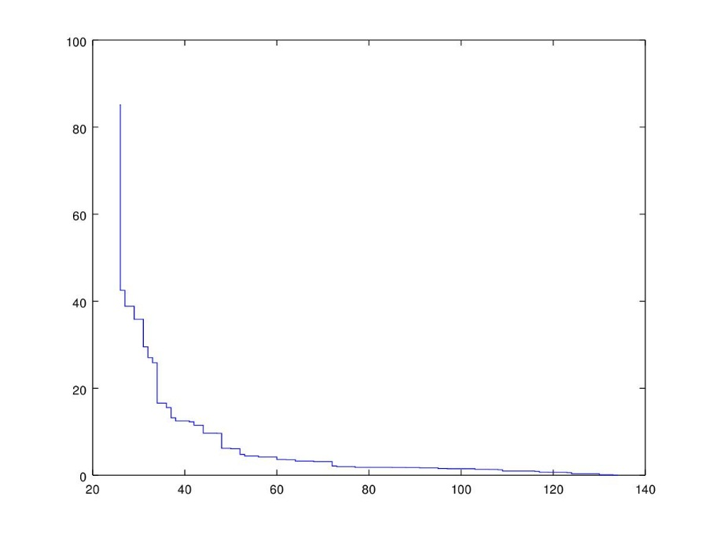

crossover 0.2 - mutation rate 0.0

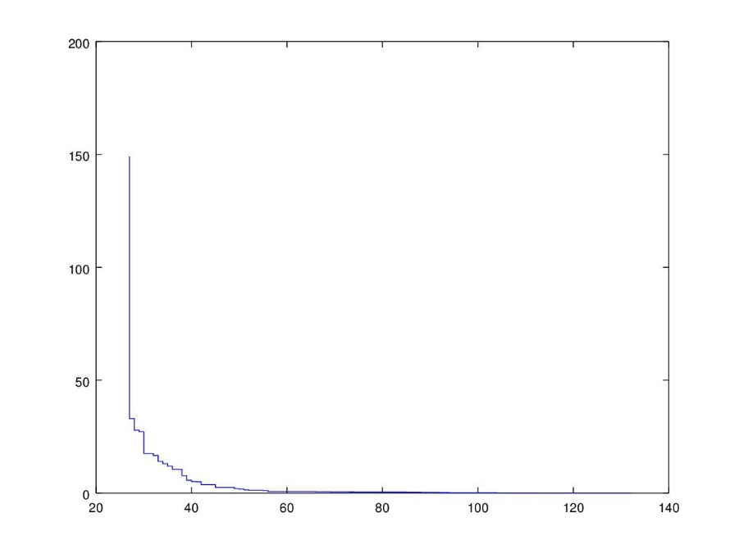

crossover 0.2 - mutation rate 0.1

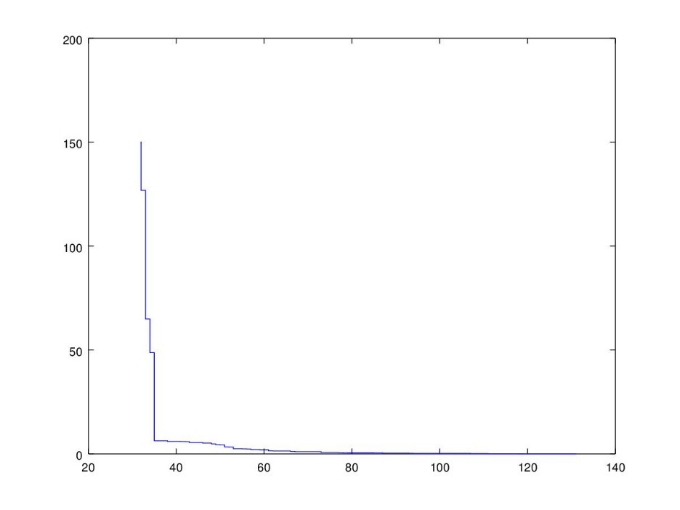

crossover 0.4 - mutation rate 0.0

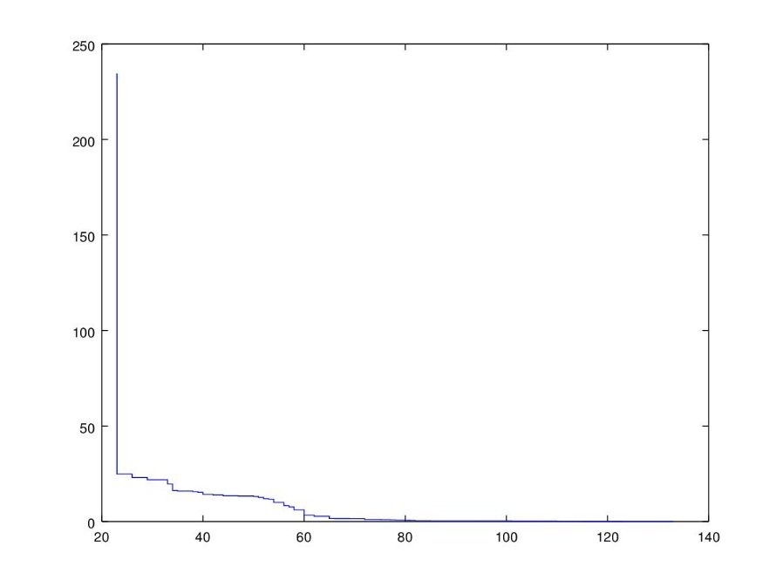

crossover 0.4 - mutation rate 0.1

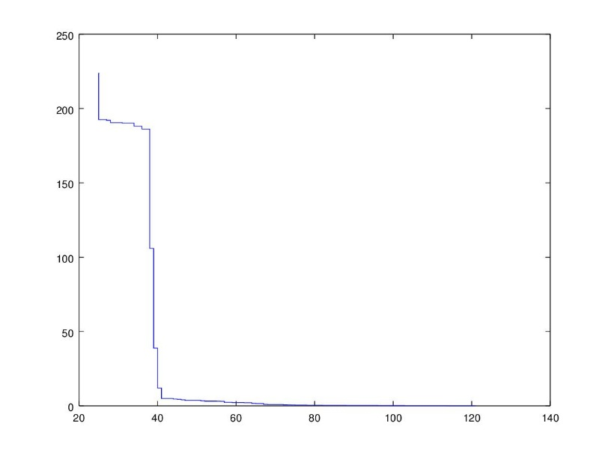

crossover 0.5 - mutation rate 0.0

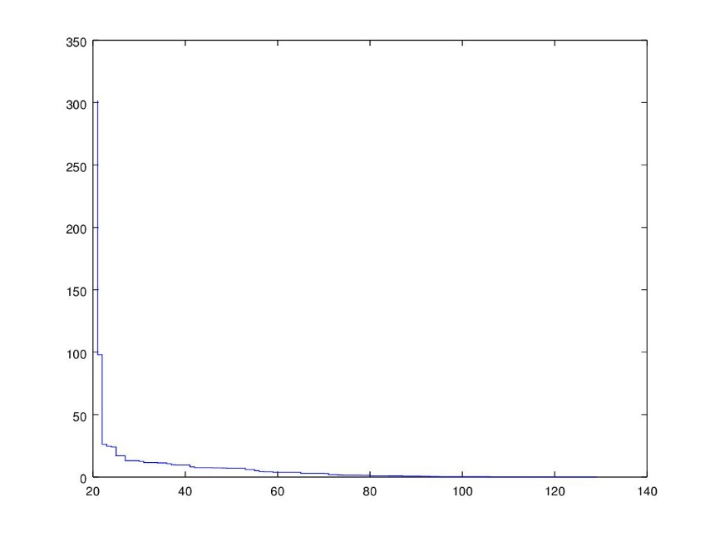

crossover 0.5 - mutation rate 0.1

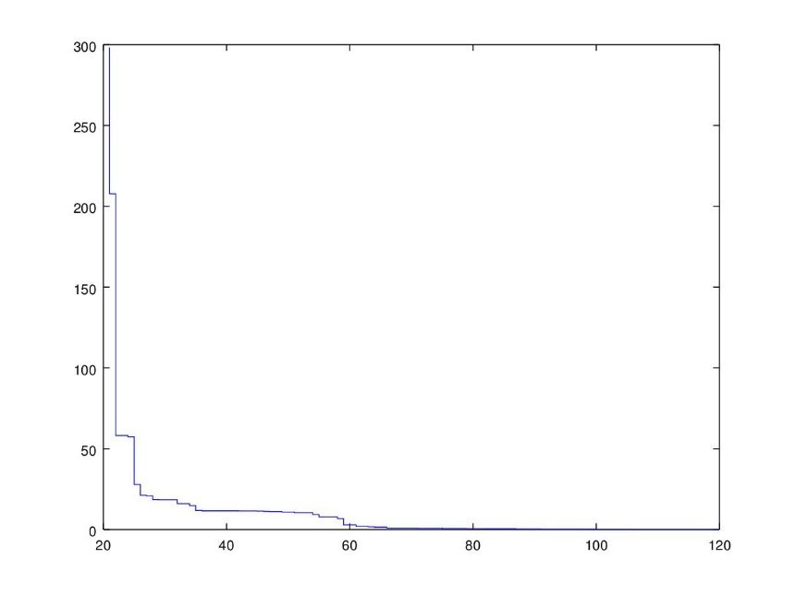

crossover 0.6 - mutation rate 0.0

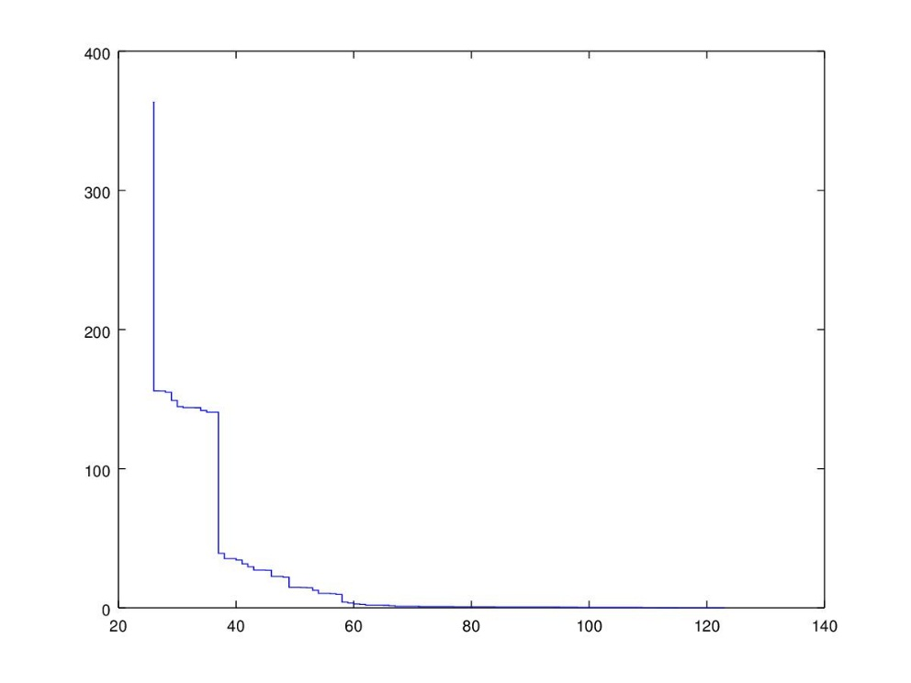

crossover 0.6 - mutation rate 0.1

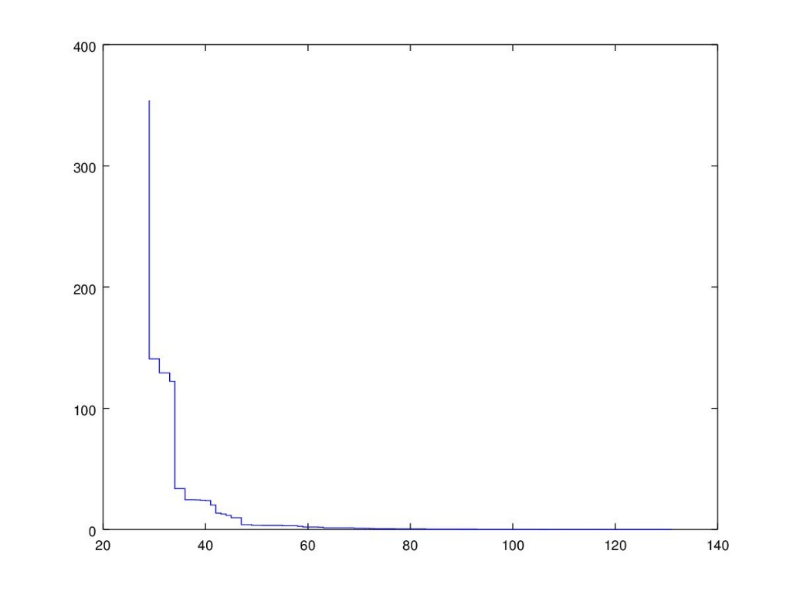

1. What is the best combination of crossover and mutation rate?
2. Which is more effective on this problem - crossover or mutation?
3. How do the results compare with simulated annealing?
   1. Population Size

When P = 2;

crossover 0.0 - mutation rate 0.0

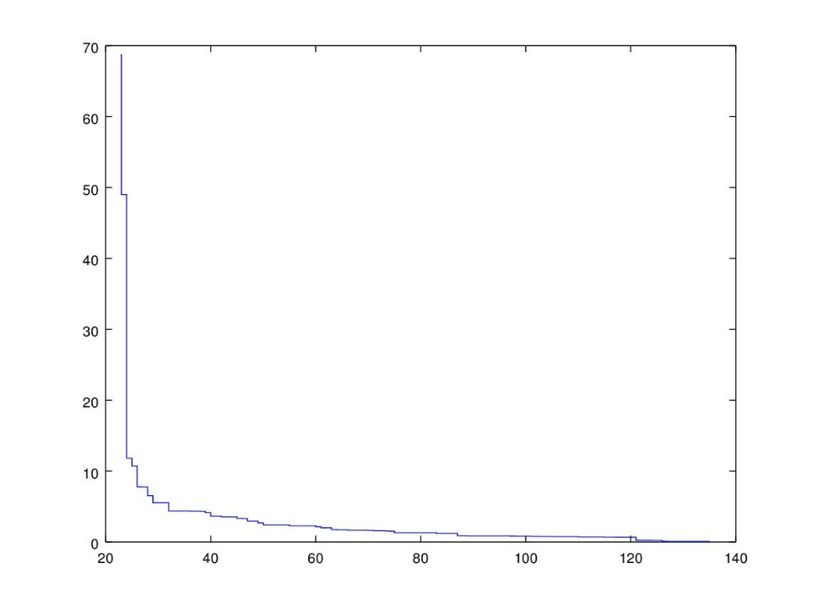

crossover 0.0 - mutation rate 0.1

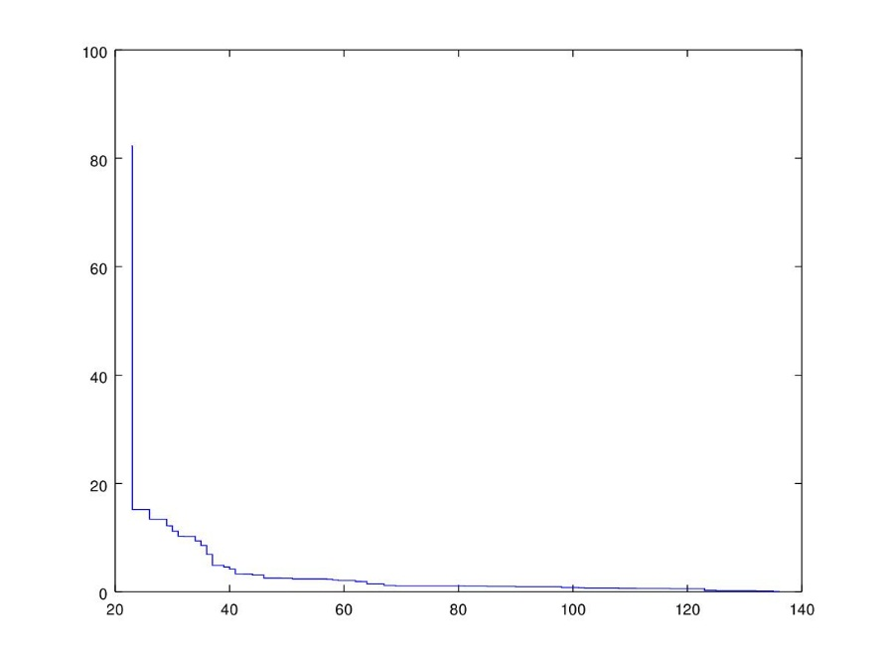

crossover 0.2 - mutation rate 0.0

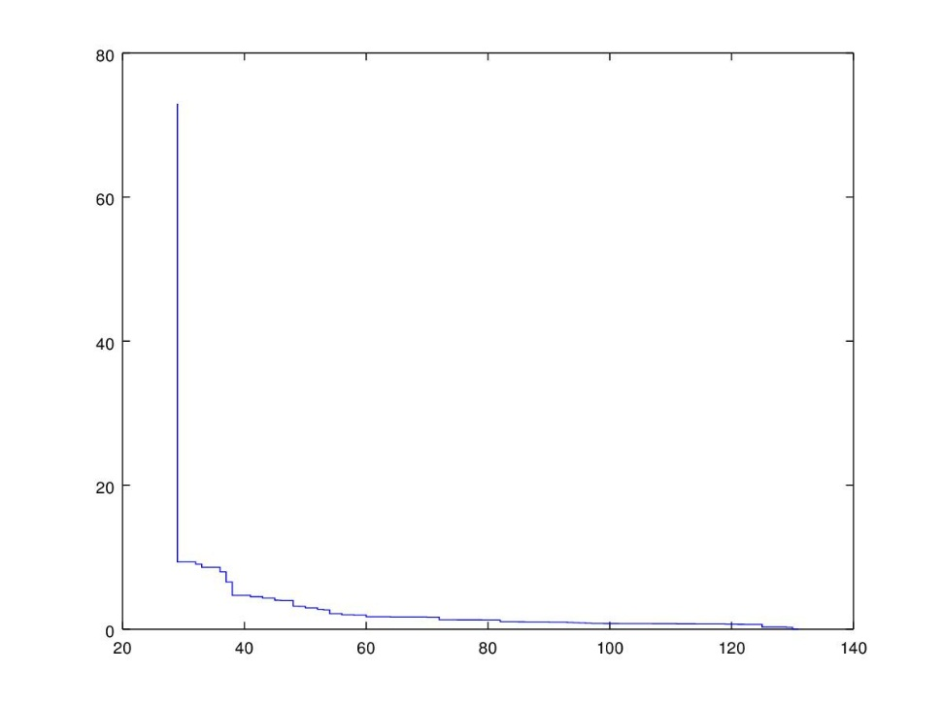

crossover 0.2 - mutation rate 0.1

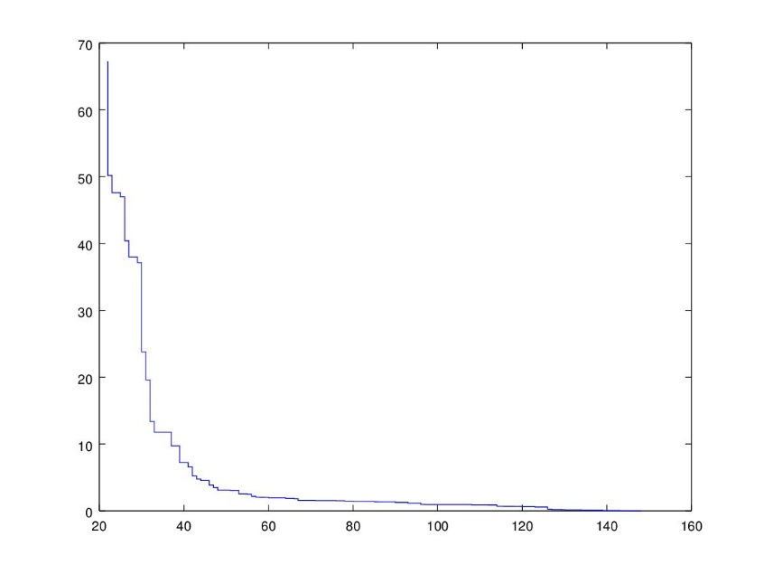

crossover 0.4 - mutation rate 0.0

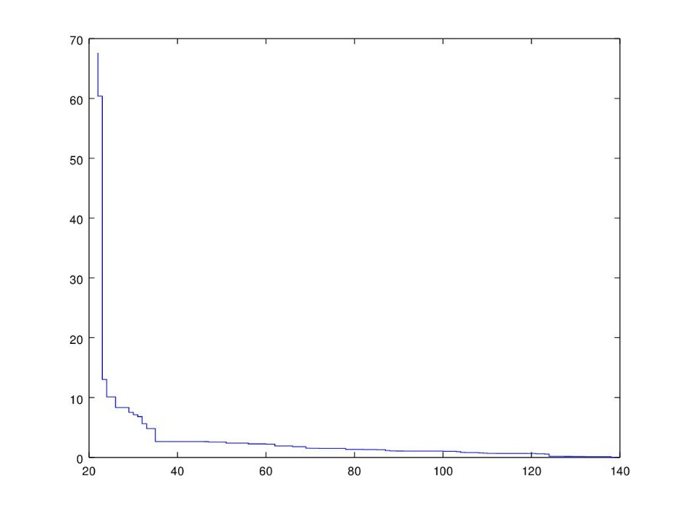

crossover 0.4 - mutation rate 0.1

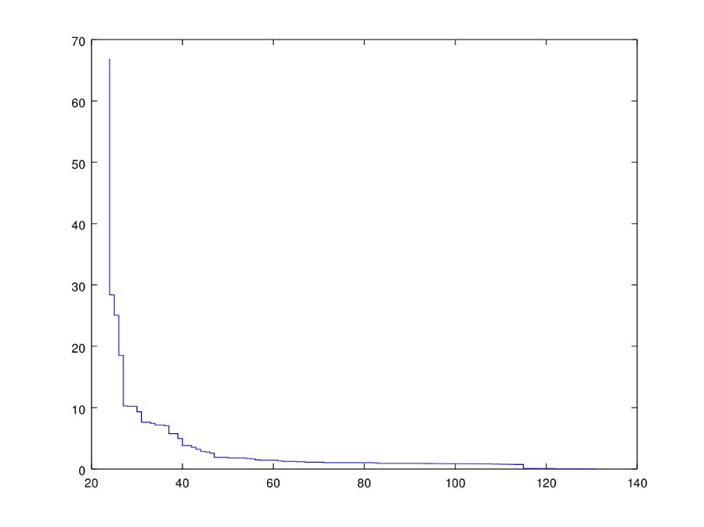

crossover 0.5 - mutation rate 0.0

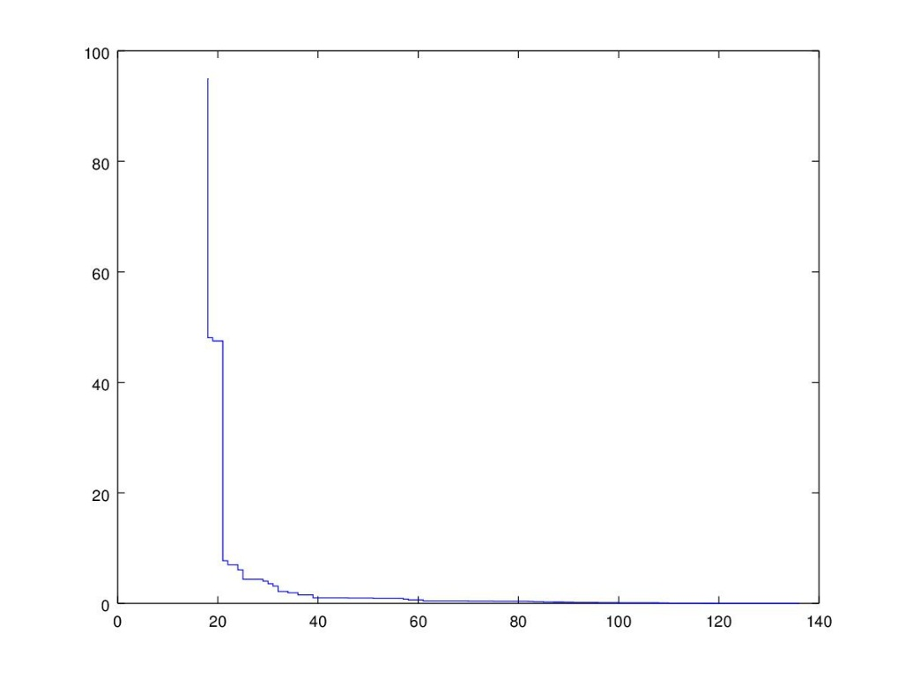

crossover 0.5 - mutation rate 0.1

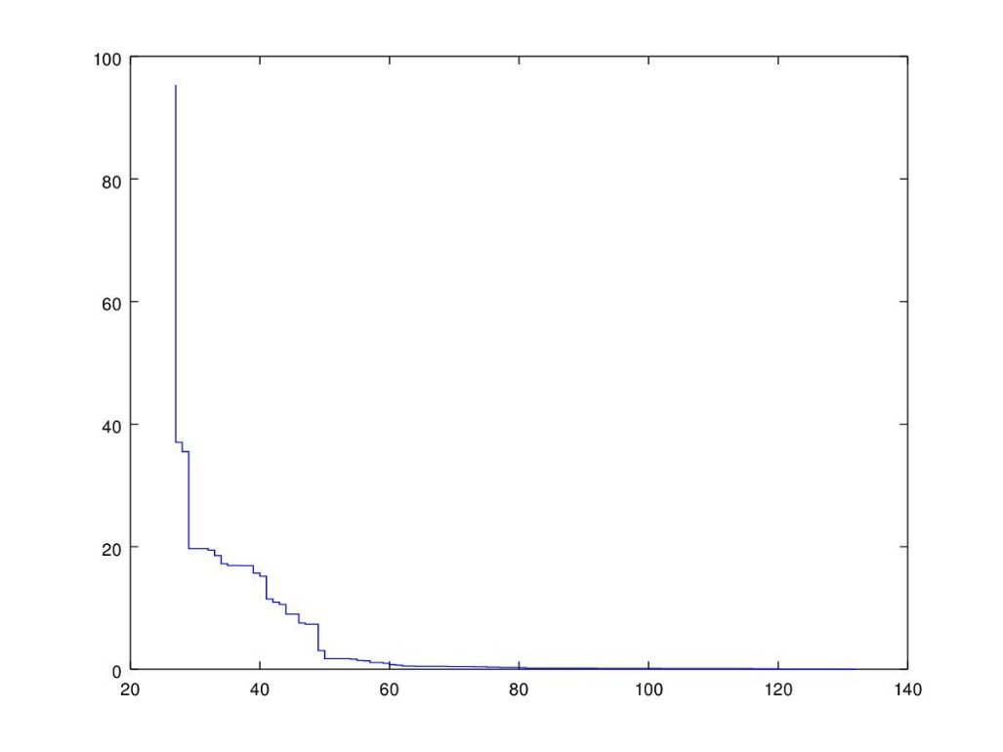

crossover 0.6 - mutation rate 0.0

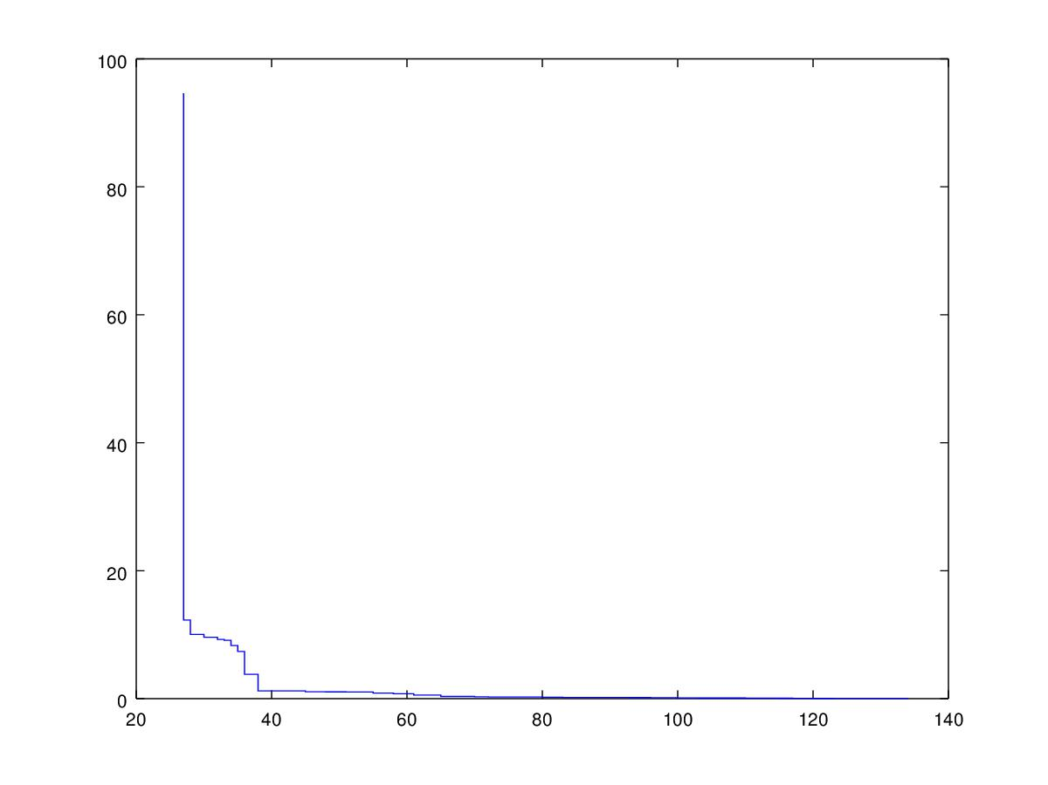

crossover 0.6 - mutation rate 0.1

